[Array 15 (2022) 100204](https://doi.org/10.1016/j.array.2022.100204)

|  |  |  |
| --- | --- | --- |
|  |  |  |
|  | Contents lists available at ScienceDirect |  |
| Array |
| journal homepage: [www.sciencedirect.com/journal/array](https://www.sciencedirect.com/journal/array) |

Analyzing the public sentiment on COVID-19 vaccination in social media: Bangladesh context   
Md. Sabab Zulfikera,*, Nasrin Kabirb, Al Amin Biswasa, Sunjare Zulfikerc,   
Mohammad Shorif Uddinb   
a *Department of Computer Science and Engineering, Daffodil International University, Dhaka, Bangladesh*   
b *Department of Computer Science and Engineering, Jahangirnagar University, Dhaka, Bangladesh*   
c *Department of Electrical and Computer Engineering, North South University, Dhaka, Bangladesh*

|  |  |
| --- | --- |
| A R T I C L E I N F O | A B S T R A C T |
| *Keywords:*  COVID-19  Vaccination  Public sentiment  Social media  Traditional machine learning Deep learning | Since December 2019, the world has been fighting against the COVID-19 pandemic. This epidemic has revealed a bitter truth that though humans have advanced to unprecedented heights in the last few decades in terms of technology, they are lagging far behind in the fields of medical science and health care. Several institutes and research organizations have stepped up to introduce different vaccines to combat the pandemic. Bangladesh government has also taken steps to provide widespread vaccinations from January 2021. The Bangladeshi net-izens are frequently sharing their thoughts, emotions, and experiences about the COVID-19 vaccines and the vaccination process on different social media sites like Facebook, Twitter, etc. This study has analyzed the views and opinions that they have expressed on different social media platforms about the vaccines and the ongoing vaccination program. For performing this study, the reactions of the Bangladeshi netizens on social media have been collected. The Latent Dirichlet Allocation (LDA) model has been used to extract the most common topics expressed by the netizens regarding the vaccines and vaccination process in Bangladesh. Finally, this study has applied different deep learning as well as traditional machine learning algorithms to identify the sentiments and polarity of the opinions of the netizens. The performance of these models has been assessed using a variety of metrics such as accuracy, precision, sensitivity, specificity, and F1-score to identify the best one. Sentiment analysis lessons from these opinions can help the government to prepare itself for the future pandemic. |

**1. Introduction**

The World Health Organization (WHO) proclaimed COVID-19 a pandemic in January 2020 [1]. COVID-19 has created substantial ram-ifications on people’s everyday lives all across the world. According to reports, COVID-19 has affected over 380 million people, with over 5.68 million individuals dying as of January 2022 [2]. Bangladesh is one of the world’s most densely inhabited countries. It is one of the worst victims of this epidemic because of its large population. In Bangladesh, there are more than 1.80 million confirmed cases of COVID-19 by January 2022, with over 28,000 deaths [3]. Various health precautions, such as keeping social distance, wearing masks, and maintaining appropriate sanitization, are necessary to avert this pandemic. However, taking adequate health precautions alone is not enough to remove this pandemic from the planet. Vaccination is the only method to stop the

spread of this disease. Countries like the USA, China, Russia have come forward to produce vaccines. The developed countries are performing mass vaccination. The government of Bangladesh has also taken steps to begin vaccinations from early 2021. By January 2022, more than 160 million doses of vaccines have been administered, and more than 62 million persons have been fully vaccinated [3].

The number of individuals who use social media has increased in tandem with the number of people using the internet. Different social media platforms have emerged as the primary means for internet users to express their emotions and reactions in recent years [4]. More than 2 billion people regularly share their daily activities through social media platforms [5]. According to a study, there are currently 3.50 billion internet users worldwide. One in every three persons in the world uses different social media sites. Some of the most popular platforms are Facebook, Twitter, and YouTube. By 2019, there are around 2.40 billion

* Corresponding author.

*E-mail addresses:* [sabab.rumc@gmail.com](mailto:sabab.rumc@gmail.com) (Md.S. Zulfiker), [etykabir16@gmail.com](mailto:etykabir16@gmail.com) (N. Kabir), [alaminbiswas.cse@gmail.com](mailto:alaminbiswas.cse@gmail.com) (A.A. Biswas), [sunjare.zulfiker](mailto:sunjare.zulfiker@gmail.com)@ [gmail.com](mailto:sunjare.zulfiker@gmail.com) (S. Zulfike[r),](mailto:sabab.rumc@gmail.com) [shorifuddin@gmail.com](mailto:shorifuddin@gmail.com) (M.S. Uddin).

<https://doi.org/10.1016/j.array.2022.100204>   
[Received 28 March 2022; Received in revised](https://doi.org/10.1016/j.array.2022.100204) form 31 May 2022; Accepted 3 June 2022   
Available online 12 June 2022   
[2590-0056](http://creativecommons.org/licenses/by-nc-nd/4.0/)/© 2022 The Authors. Published by Elsevier Inc. This is an open access article under the CC BY-NC-ND license (<http://creativecommons.org/licenses/by-nc-nd/4.0/>).

*Md.S. Zulfiker et al.*  *Array 15 (2022) 100204*

Facebook users, 330 million Twitter users, and over 1.90 billion You-Tube users [6].

Due to the simplicity of these social media sites, users rely heavily on these platforms for sharing news and information. These platforms have become the prime sources of health-related information also. In the current COVID-19 situation, people are vastly sharing and discussing their views on the pandemic, vaccines and the vaccination process. Users post both positive and negative news and opinions. Sometimes negative and fake information about the vaccines and the vaccination process creates vaccine hesitancy, leading individuals to be disinterested in getting vaccinated. In 2019, vaccine hesitancy was enlisted as one of the ten most significant implications to global health [7]. Fake, as well as misleading information regarding the vaccination procedure, has the ability to lessen a country’s vaccination rate.

With the beginning of the vaccination program for COVID-19 in Bangladesh, Bangladeshi netizens are also using social networking platforms to express their views and reactions. They have shown mixed reactions to the ongoing vaccination program. However, very few studies have been conducted to analyze the opinions and feelings of Bangladeshi netizens about the COVID-19 vaccination program. This work attempts to fill this gap. Based on different demographic attributes, this study looked at how social media users felt about the COVID-19 vaccines and the ongoing vaccination campaigns in Bangladesh. This study also aims to extract the most essential themes expressed by the Bangladeshi netizens regarding these campaigns. Finally, this research has suggested several machine learning and deep learning approaches for assessing the polarity of social media users’ views about Bangla-desh’s vaccination program and has picked the best model that can accurately identify the polarity of users’ emotions.

By utilizing the methodologies and approaches described in this study, Bangladesh government and policymakers can be aware of the actual opinions and sentiments of the Bangladeshi residents towards the ongoing vaccination campaigns. They can learn about the most con-cerning issues raised by the citizens about these campaigns. Based on this information, the government may take appropriate actions to ensure that the people of Bangladesh receive enough services regarding vacci-nation. Government can also be aware of the common misconceptions of the Bangladeshi citizens about the vaccine. By analyzing these mis-conceptions, they can take suitable initiatives to raise awareness among the native citizens against these fallacies. Besides, lessons from these opinions can help the government to prepare itself for the future pandemic.

The key contributions of this study are as follows:

i. Constructing a corpus of the Bangladeshi public opinion regarding the COVID-19 vaccines and the vaccination campaigns. ii. Analyzing the views of Bangladeshi citizens regarding the vac- cines and the vaccination campaigns.

iii. Exploring various deep learning and machine learning ap-proaches to anticipate the Bangladeshi population’s attitudes towards the vaccine and vaccination campaigns.

The remainder of the paper is arranged as follows: Section 2 portrays the related works of the study. The methodology for analyzing the opinions of the Bangladeshi netizens regarding the COVID-19 vaccine and the ongoing vaccination program is delineated in Section 3. The result of the study is exhibited in Section 4. Finally, Section 5 concludes the paper by outlining some potential future scopes.

**2. Related works**

It can be undoubtedly said that COVID-19 has posed an extreme threat to human lives. This threat also sparked the rapid development of its vaccines. Misinformation communicated through online social media, on the other hand, frequently contributes to negative vaccine sentiments and hesitation. Understanding how people feel about the

2

*Md.S. Zulfiker et al.*  *Array 15 (2022) 100204*

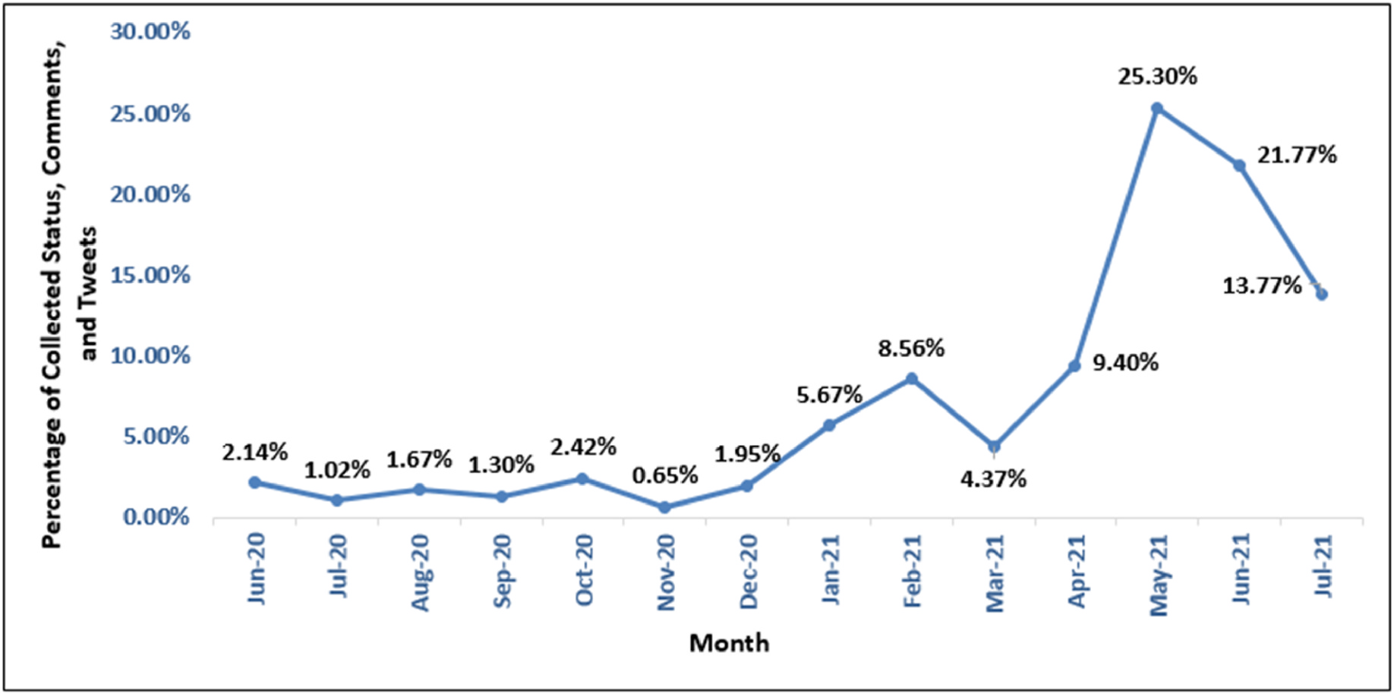

**Fig. 1.** Monthly percentage of the collected opinions.

The attitudes of people towards the vaccines of various kinds were examined in this study using natural language processing (NLP) tech-niques and they visualized the scenario by grouping the polarities of the received feelings into three categories, i.e. positive, negative, and neutral. The performance of the predictive models was evaluated using a Recurrent Neural Network (RNN) including Long Short-Term Memory (LSTM) and Bi-Directional LSTM (Bi LSTM). Here, LSTM and Bi LSTM obtained an accuracy of 90.59% and 90.83%, respectively.

Hayawi et al. [15] presented a unique COVID-19 vaccination misinformation detection framework based on machine learning (ML). They used ML techniques to classify vaccination misinformation after collecting and annotating COVID-19 vaccine tweets. They categorized more than 15,000 tweets into two categories using credible sources and taking the help of specialists. This research work used Extreme Gradient Boosting (XGBoost), LSTM, and the BERT transformer model for classi-fication. Among these models, the BERT model showed the best per-formance. They concluded that machine learning-based algorithms are successful at detecting COVID-19 vaccine misinformation.

Basiri et al. [16] proposed a unique technique for analyzing the sentiment of the tweets relating coronavirus from eight countries by combining different deep learning and traditional machine learning model. They also used Google Trends to examine coronavirus-related queries to better understand how sentiment changed over time in different locations. The coronavirus drew peoples’ attention from various countries at different periods and with variable degrees of in-tensity, according to their results. Additionally, their tweets reflect their attitudes on events and news in their countries, such as the number of new cases of infection, fatalities, and recoveries. Furthermore, throughout the transmission of the infection, a common sentiment pattern is noticed in numerous countries.

Nezhad and Deihimi [17] presented a study that analyzed Iranian people’s views on COVID-19 vaccination using Persian tweets. To begin, they extracted 803,278 Persian tweets from Twitter using various key-words to determine their sentiments. For analyzing the sentiments of the tweets, they utilized a deep learning model based on CNN-LSTM archi-tecture. Finally, they discovered a slight variation in the number of positive opinions towards domestic and imported vaccines. The study stated that the imported vaccines had the majority of positive sentiments.

Melton et al. [18] performed sentiment analysis and LDA topic modelling on textual data obtained from 13 Reddit communities concentrating on the COVID-19 vaccination. To discover changes in

3

*Md.S. Zulfiker et al.*  *Array 15 (2022) 100204*

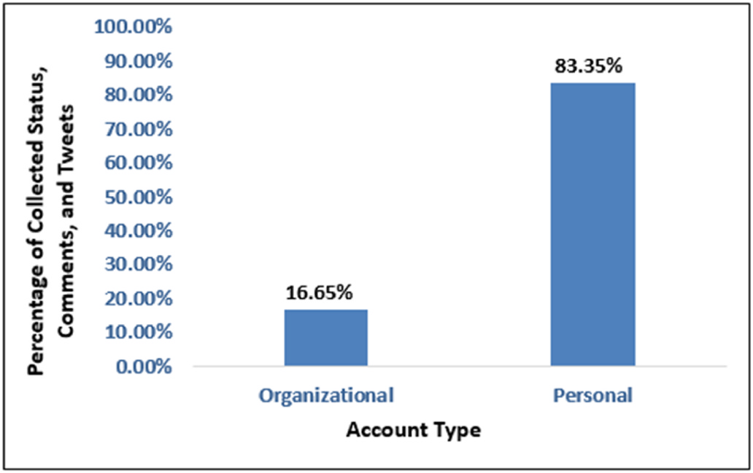

**Fig. 2.** Percentage of the collected opinions by account type.

Yin et al. [23] analyzed the dynamics of topics and sentiments on social networking sites. They found that tweets associated with home quarantine conveyed mostly positive views, and tweets discussing the mortalities due to the pandemic mostly expressed negative sentiments.

Based on the preceding discussions, it can be stated that no research work has been conducted yet to analyze the opinions of Bangladeshi netizens regarding the vaccine and the vaccination process using ma-chine learning, deep learning and natural language processing tech-niques. This research has paved the way to fill this void. This study has utilized different deep learning and traditional machine learning tech-niques to identify the polarity of the opinions of the Bangladeshi neti-zens. Furthermore, this study has extracted the latent topics discussed by the Bangladeshis in social media regarding the COVID-19 vaccine and the vaccination campaigns.

**3. Methodology**

The following subsections cover the overall strategy for extracting the most common topics discussed by the Bangladeshi netizens and identifying the polarity of their sentiments towards the COVID-19 vac-cine and the vaccination program using a variety of deep learning and traditional machine learning algorithms.

*3.1. Data collection*

For conducting this study, we have constructed a dataset including 1075 statuses, comments, and tweets of the Bangladeshi netizens. We collected the data between June 2020 and July 2021. Opinions written in the English language have been considered only to generate the dataset. Fig. 1 shows the monthly percentage of the gathered opinions from June 2020 to July 2021. From the trend in Fig. 1, we can state that people were reluctant to express their sentiments and emotions regarding the vaccines in 2020. But from January 2021, the number of opinions regarding the vaccine and vaccination process increased rapidly with the initiation of the vaccination program.

Fig. 1 indicates that the most opinions were acquired in May 2021, and the least opinions were acquired in November 2020. 25.30% of the total opinions were gathered in May 2021, but on the other hand, only 0.65% of the total opinions were collected in November 2020. In May 2021, China provided free vaccines as a gift to Bangladesh in several phases. Besides, a Bangladeshi pharmaceutical company took the initiative to import the Moderna vaccine for the first time in Bangladesh. The netizens frequently expressed their opinions regarding these events, causing a surge in the amount of posted tweets, status updates, and comments on social media.

Fig. 2 depicts the percentage of opinions acquired from the organi-zational and personal accounts. It shows that 16.65% of the total opin-ions were collected from the accounts of different organizations like

4

*Md.S. Zulfiker et al.*  *Array 15 (2022) 100204*

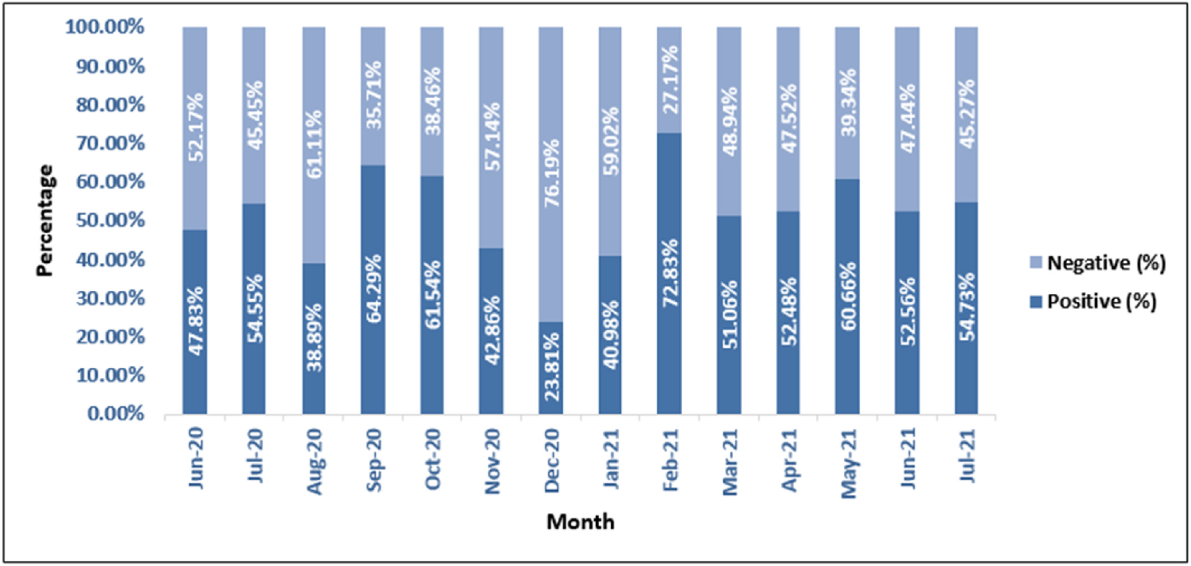

**Fig. 3.** Monthly percentage of the polarity of the opinions.

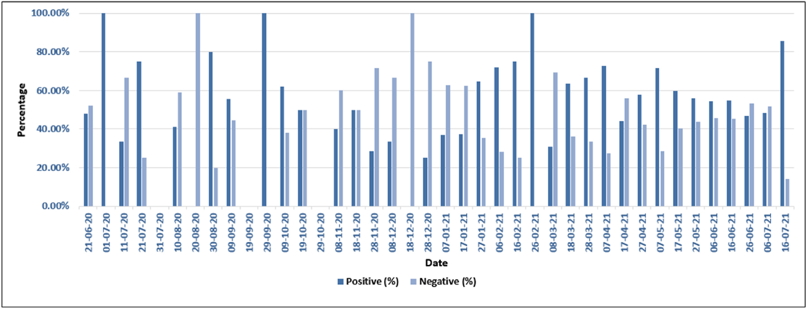

**Fig. 4.** Sentiment dynamics of every ten (10) days.

has been used to extract the most discussed topics among the Bangla-deshi citizens regarding the vaccine and the vaccination process. In 2003, Blei et al. proposed the LDA model [26]. Documents are seen by LDA as a collection of topics. Topics, on the other hand, are treated as a blend of words. The probability of each word appearing in a topic is measured. If a word has a high probability of appearing in a topic, all documents containing that word are tightly linked to that topic.

This study has extracted the top five dominant topics from the corpus containing positive statements and the top five dominant topics from the corpus containing negative statements of the Bangladeshi netizens about the vaccine and the vaccination process. The top five prevalent topics were selected from the corpuses of the positive and the negative state-ments based on the perplexity score. A lower perplexity score suggests a higher generalization ability. The perplexity scores for top *n*− topics (2 ≤ *n* ≤ 5) were measured. Table 2 shows that, the perplexity scores were the lowest for the top five dominant topics.

Table 3 shows the top fifteen words of the top five topics in the corpus containing the positive statements extracted by LDA.

Some insights of the topics of Table 3 are as follows:

5

*Md.S. Zulfiker et al.*  *Array 15 (2022) 100204*

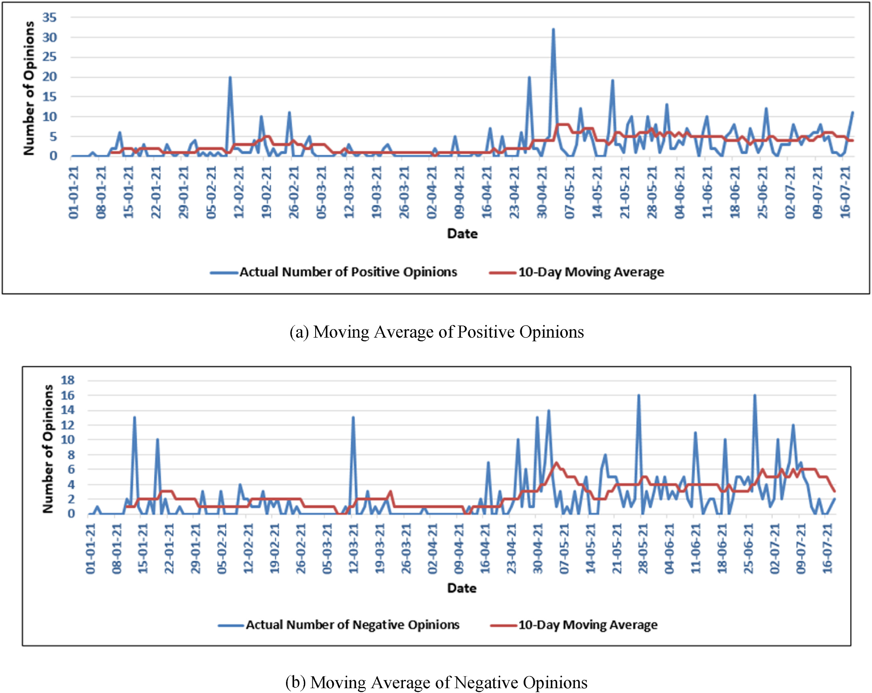

**Fig. 5.** Ten (10) day moving average of the positive and negative opinions.

Topic 2: According to the netizens, different foreign countries were allegedly playing politics when it came to delivering vaccine doses to Bangladesh. They also claimed that foreign countries were demanding a high price for vaccines.

Topic 3: The netizens stated that different pharmaceutical companies and foreign countries were doing business regarding the vaccine. So, they encouraged others to avoid taking vaccines.

Topic 4: Netizens were discussing the side effects of the vaccines. Topic 5: When the government failed to acquire vaccines despite making advance payments to other countries for vaccines, netizens expressed their dissatisfaction. Moreover, they demanded that the government should take back the money that was paid in advance.

*3.4. Implementation procedures*

This section describes the procedures of predicting the polarity of the Bangladeshi netizens’ remarks on the vaccine and the vaccination pro-cess. The entire technique is depicted in Fig. 7.

The following subsections describe the whole procedures.

*3.4.1. Data cleaning*   
 Facebook and Twitter users frequently use different emojis and emoticons in their statuses and tweets. As this research only focuses on

6

*Md.S. Zulfiker et al.*  *Array 15 (2022) 100204*

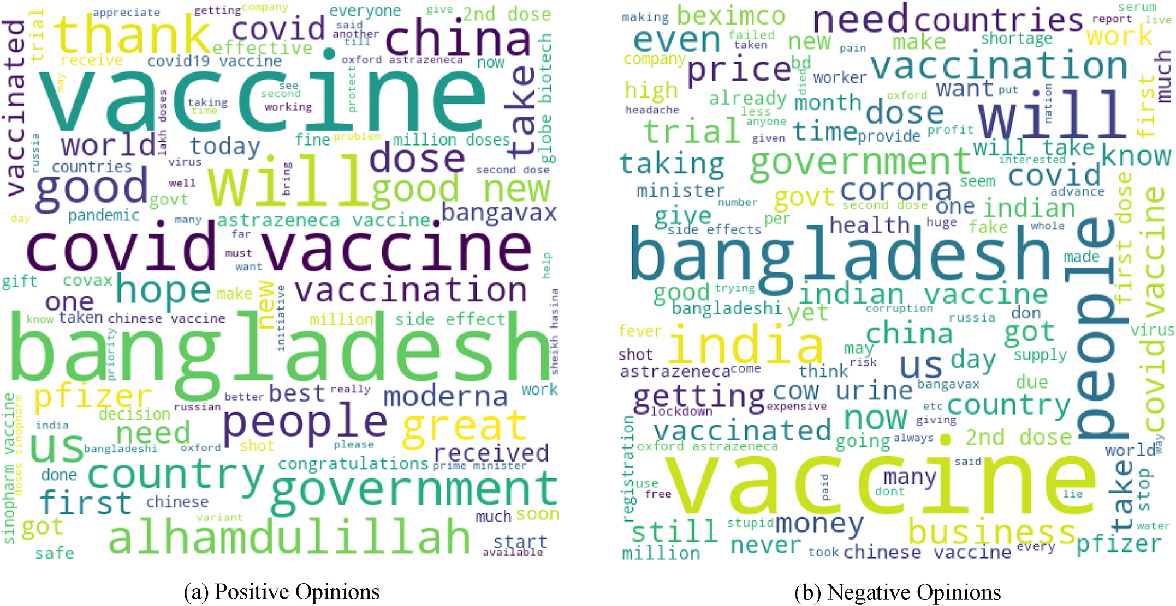

**Fig. 6.** Word clouds.

**Table 2**   
Perplexity scores for different number of topics in the corpus of the positive and negative statements.

|  |  |  |
| --- | --- | --- |
| Number of Topics | Perplexity Score for Corpus of the Positive Statements | Perplexity Score for Corpus of the Negative Statements |
| 2  3  4  5 | −6.04  −6.10  −6.20  −6.26 | −6.11  −6.21  −6.30  −6.36 |

**Table 3**   
Top five topics of the positive corpus.

|  |  |  |  |  |
| --- | --- | --- | --- | --- |
| Topic 1 | Topic 2 | Topic 3 | Topic 4 | Topic 5 |
| vaccines  bangladesh  vaccine  best  minister  hope  bangavax  great  see  taking  us  initiative  appreciate  countries  congratulations | Vaccine  Bangladesh Vaccines  doses  china  good  million  covid19  sinopharm  moderna  government covid  us  pfizer  covax | vaccine  good  news  us  people  bangladesh country  biotech  also  globe  government thanks  allah  need  get | no  side  effects  everyone  alhamdulillah took  vaccine  get  medical  parents  bangladesh  fine  vaccinated  know  vaccination | vaccine  bangladesh dose  great  got  vaccinated vaccination pfizer  second  thank  doses  news  people  first  soon |

of the words of a statement to a particular integer id. A two-way lookup table has been used to convert the word of the statements to particular integer ids and vice versa.

*3.4.5. Data splitting*   
 Here, the acquired dataset has been split into train and test data. 20% data of the dataset has been used for constructing the test dataset. The remaining 80% of the data has been utilized for training the models.

7

*Md.S. Zulfiker et al.*  *Array 15 (2022) 100204*

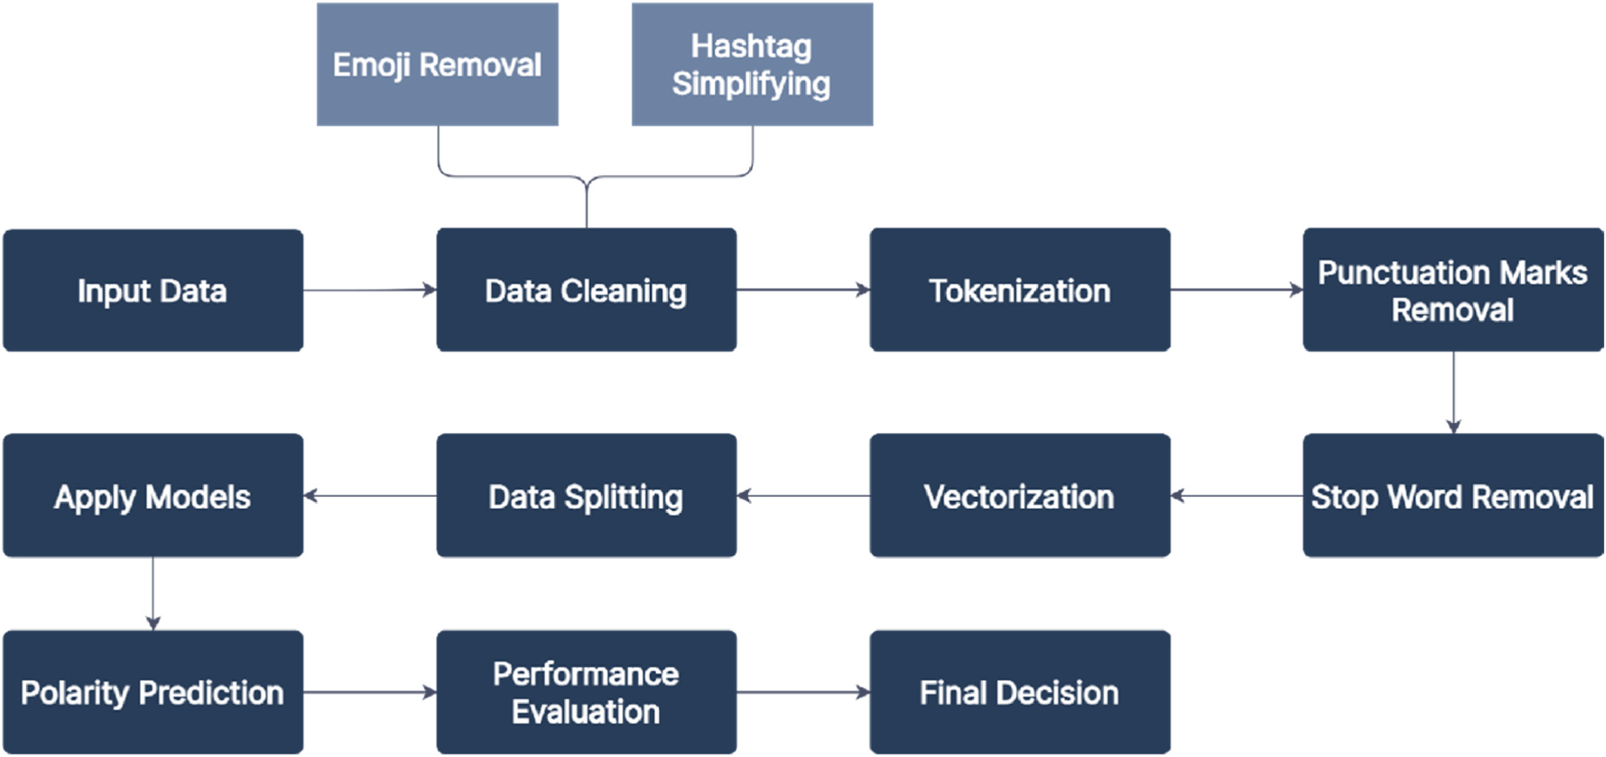

**Fig. 7.** Implementation procedures for predicting the polarity of the statements.

function.

The proposed Bi LSTM model has an almost similar architecture to the proposed LSTM model. It also has two Bi LSTM layers. The first Bi LSTM layer consists of 100 units and the second Bi LSTM layer consists of 32 units.

In the suggested 1D-CNN model, there are two 1D-CNN layers. The first CNN layer has 256 filters and the second CNN layer has 128 filters. Both layers have a kernel size of three. Before the first CNN layer, there is a Spatial Dropout layer with a dropout rate of 0.3. A dropout layer follows the first CNN layer, and a Global Max Pooling layer follows the second CNN layer. After the Global Max Pooling layer, there is a dense layer with 512 hidden nodes, which is followed by another dropout layer. Following this dropout layer, there is another dense layer with 256 hidden nodes. This dense layer is also followed by another dropout layer. The dropout rates of all of these dropout layers are 0.3. The final dense layer utilizes the Softmax activation function and has 2 hidden nodes. Before the final dense layer, batch normalization has been applied.

The proposed TCN model consists of a single TCN layer with 256 filters. The kernel size of this layer is three. The TCN layer is preceded by a Spatial Dropout layer. After the TCN layer, there is a dropout layer. The model consists of four dense layers, including the final dense layer. The dense layers have 512, 256, 128, and 2 nodes, respectively. The first three dense layers are followed by dropout layers. The dropout rate of all of these dropout layers is 0.3. Before the final dense layer, batch normalization is applied. The final dense layer uses the Softmax acti-vation function.

In these deep learning models, Binary Cross Entropy has been used as the loss function, and Adam has been used as the optimizer.

*3.4.7. Performance evaluation and final decision*   
 In this step, the proposed deep learning and machine learning models’ performances have been assessed using several performance metrics like accuracy, precision, specificity, sensitivity, and F1-score. Based on these performance metrics, the best model for classifying the sentiments of the netizens has been chosen.

**4. Results and discussion**

For analyzing the performance of the proposed models, 215 state-ments of the netizens have been used. Among the statements of the test dataset, 56.74% statements have a positive polarity and the rest, 43.26% statements have a negative polarity. Different performance metrics such

8

*Md.S. Zulfiker et al.*  *Array 15 (2022) 100204*

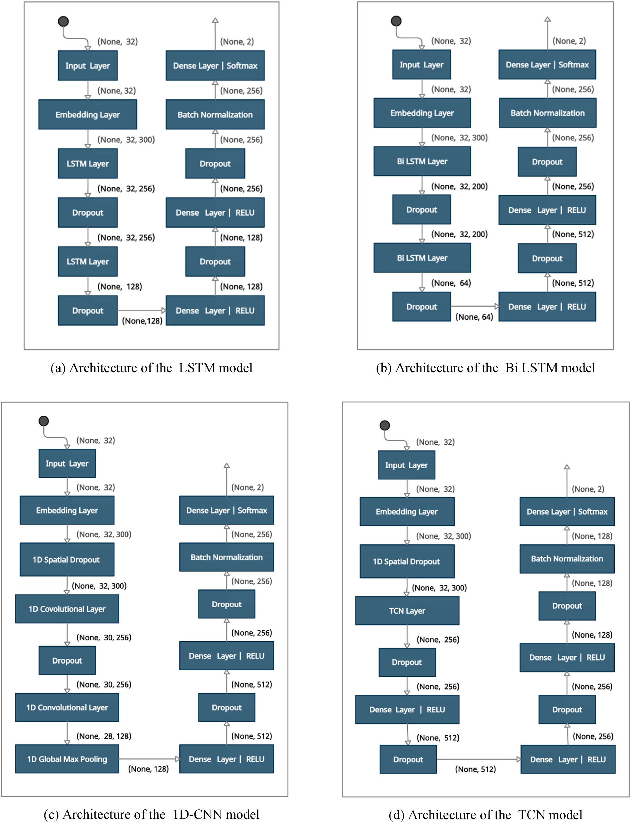

**Fig. 8.** Architecture of the proposed deep learning models.

9

*Md.S. Zulfiker et al.*  *Array 15 (2022) 100204*

**Table 5**

Confusion matrices of the proposed deep learning models.

|  |  |  |  |  |  |
| --- | --- | --- | --- | --- | --- |
| Model | Pre-trained Word Embedding | TPPolarity | TNPolarity | FPPolarity | FNPolarity |
| LSTM | word2vec  GloVe  word2vec  GloVe  word2vec  GloVe  word2vec  GloVe | 112  108  108  113  109  114  108  105 | 73  75  80  71  74  67  78  79 | 20  18  13  22  19  26  15  14 | 10  14  14  9  13  8  14  17 |
| Bi LSTM |
| 1D-CNN |
| TCN |

**Table 6**   
Confusion matrices of the proposed traditional machine learning models.

|  |  |  |  |  |
| --- | --- | --- | --- | --- |
| Model | TPPolarity | TNPolarity | FPPolarity | FNPolarity |
| DT  GB  SVM | 75  89  97 | 37  41  40 | 56  52  53 | 47  33  25 |

score of the proposed deep learning and traditional machine learning models are shown in Table 7 and Table 8, respectively.

From Tables 7 and 8, it can be stated that the deep learning models have outperformed the traditional machine learning models to a great extent.

Bi LSTM with the pre-trained word2vec embedding model has shown the highest accuracy of 87.44% among the deep learning models. In terms of accuracy, the word2vec embedding based deep learning models have shown better performances than the GloVe embedding based deep learning models. The accuracies of LSTM, 1D-CNN and TCN models with word2vec embedding are 86.05%, 85.12%, and 86.51%, respectively. On the other hand, the accuracies of LSTM, Bi LSTM, 1D-CNN and TCN models with GloVe embedding are 85.12%, 85.58%, 84.19%, and 85.58%, respectively.

Precision, sensitivity, specificity, and F1-score play essential roles in evaluating the performance of machine learning or deep learning models, in addition to accuracy. Bi LSTM with the pre-trained word2vec embedding model has portrayed the best performance in terms of pre-cision, and it has achieved a precision of 89.26%. This model has also shown the highest specificity and F1- score of 86.02% and 88.89%, respectively. GloVe embedding based deep learning models have shown better performance than word2vec embedding based deep learning models in terms of sensitivity. 1D-CNN with the pre-trained GloVe embedding model has achieved the highest sensitivity of 93.44%. After the GloVe embedding based 1D-CNN model, the GloVe embedding based Bi LSTM has shown the best sensitivity of 92.62%.

SVM showed the highest accuracy of 63.72% among the traditional machine learning algorithms. The achieved accuracies of DT and GB are 52.09% and 60.47%, respectively. SVM, DT, and GB attained precisions of 57.25%, 63.12%, and 64.67%, respectively. In terms of sensitivity, SVM outperformed DT and GB. It attained a sensitivity of 79.51%, while the attained sensitivities of DT and GB are 61.48% and 72.95%, respectively. The traditional machine learning models also showed poor performance in the case of other performance metrics like specificity

**Table 7**   
Performance metrics of the proposed deep learning models.

and F1- score.

The Receiver Operating Characteristic (ROC) curve with Area Under Curve (AUC) values of the deep learning models are shown in Fig. 9 (a)- (d). When a model’s AUC value is equal to 1, the model is regarded to be the perfect model for classification. If the AUC value of a model is equal to 0.5, then the model will provide random outcomes. That means the later model is unable to differentiate between different classes. The AUC values of all the proposed deep learning models are more than 0.9. So it can be stated that all of the suggested deep learning models are almost flawless.

The ROC curve of a classifier is a two-dimensional graph that plots the true-positive rate of that classifier against its false-positive rate at various threshold levels. The better the performance of a classifier, the closer the ROC curve of that model is to the top left corner of the graph. Fig. 9 (a)–(d) shows that the ROC curves of LSTM, Bi LSTM, and TCN with the word2vec pre-trained embedding is closer to the upper left corner of the graph than the ROC curves of these models when they were using pre-trained GloVe embedding. Only in the case of the 1D-CNN model, while using pre-trained GloVe embedding, the ROC curve is closer to the top left corner of the graph than using pre-trained word2vec embedding.

Fig. 10 shows the ROC curves as well as the AUC scores of the traditional machine learning models. The AUC values of DT, GB, and SVM are 0.506, 0.646, and 0.639, respectively. The ROC curves of these models also prove their inefficiency. So, it is obvious that the traditional machine learning algorithms have shown pretty poor performance in terms of different performance metrics.

By analyzing the performance of different deep learning and tradi-tional machine learning algorithms, it can be concluded that the word2vec embedding based Bi LSTM model has surpassed the other models based on different performance metrics.

**Table 8**   
Performance metrics of the proposed traditional machine learning models.

|  |  |  |  |  |  |
| --- | --- | --- | --- | --- | --- |
| Model | Accuracy | Precision | Sensitivity | Specificity | F1- score |
| DT  GB  SVM | 52.09% 60.47% 63.72% | 57.25% 63.12% 64.67% | 61.48%  72.95%  79.51% | 39.78% 44.09% 43.01% | 59.29% 67.68% 71.32% |

|  |  |  |  |  |  |  |
| --- | --- | --- | --- | --- | --- | --- |
| Model | Pre-trained Word Embedding | Accuracy | Precision | Sensitivity | Specificity | F1- score |
| LSTM | word2vec  GloVe  word2vec  GloVe  word2vec  GloVe  word2vec  GloVe | 86.05%  85.12%  87.44%  85.58%  85.12%  84.19%  86.51%  85.58% | 84.85%  85.71%  89.26%  83.70%  85.16%  81.43%  87.80%  88.24% | 91.80%  88.52%  88.52%  92.62%  89.34%  93.44%  88.52%  86.07% | 78.49%  80.65%  86.02%  76.34%  79.57%  72.04%  83.87%  84.95% | 88.19%  87.10%  88.89%  87.94%  87.20%  87.02%  88.16%  87.14% |
| Bi LSTM |
| 1D-CNN |
| TCN |

10

*Md.S. Zulfiker et al.*  *Array 15 (2022) 100204*

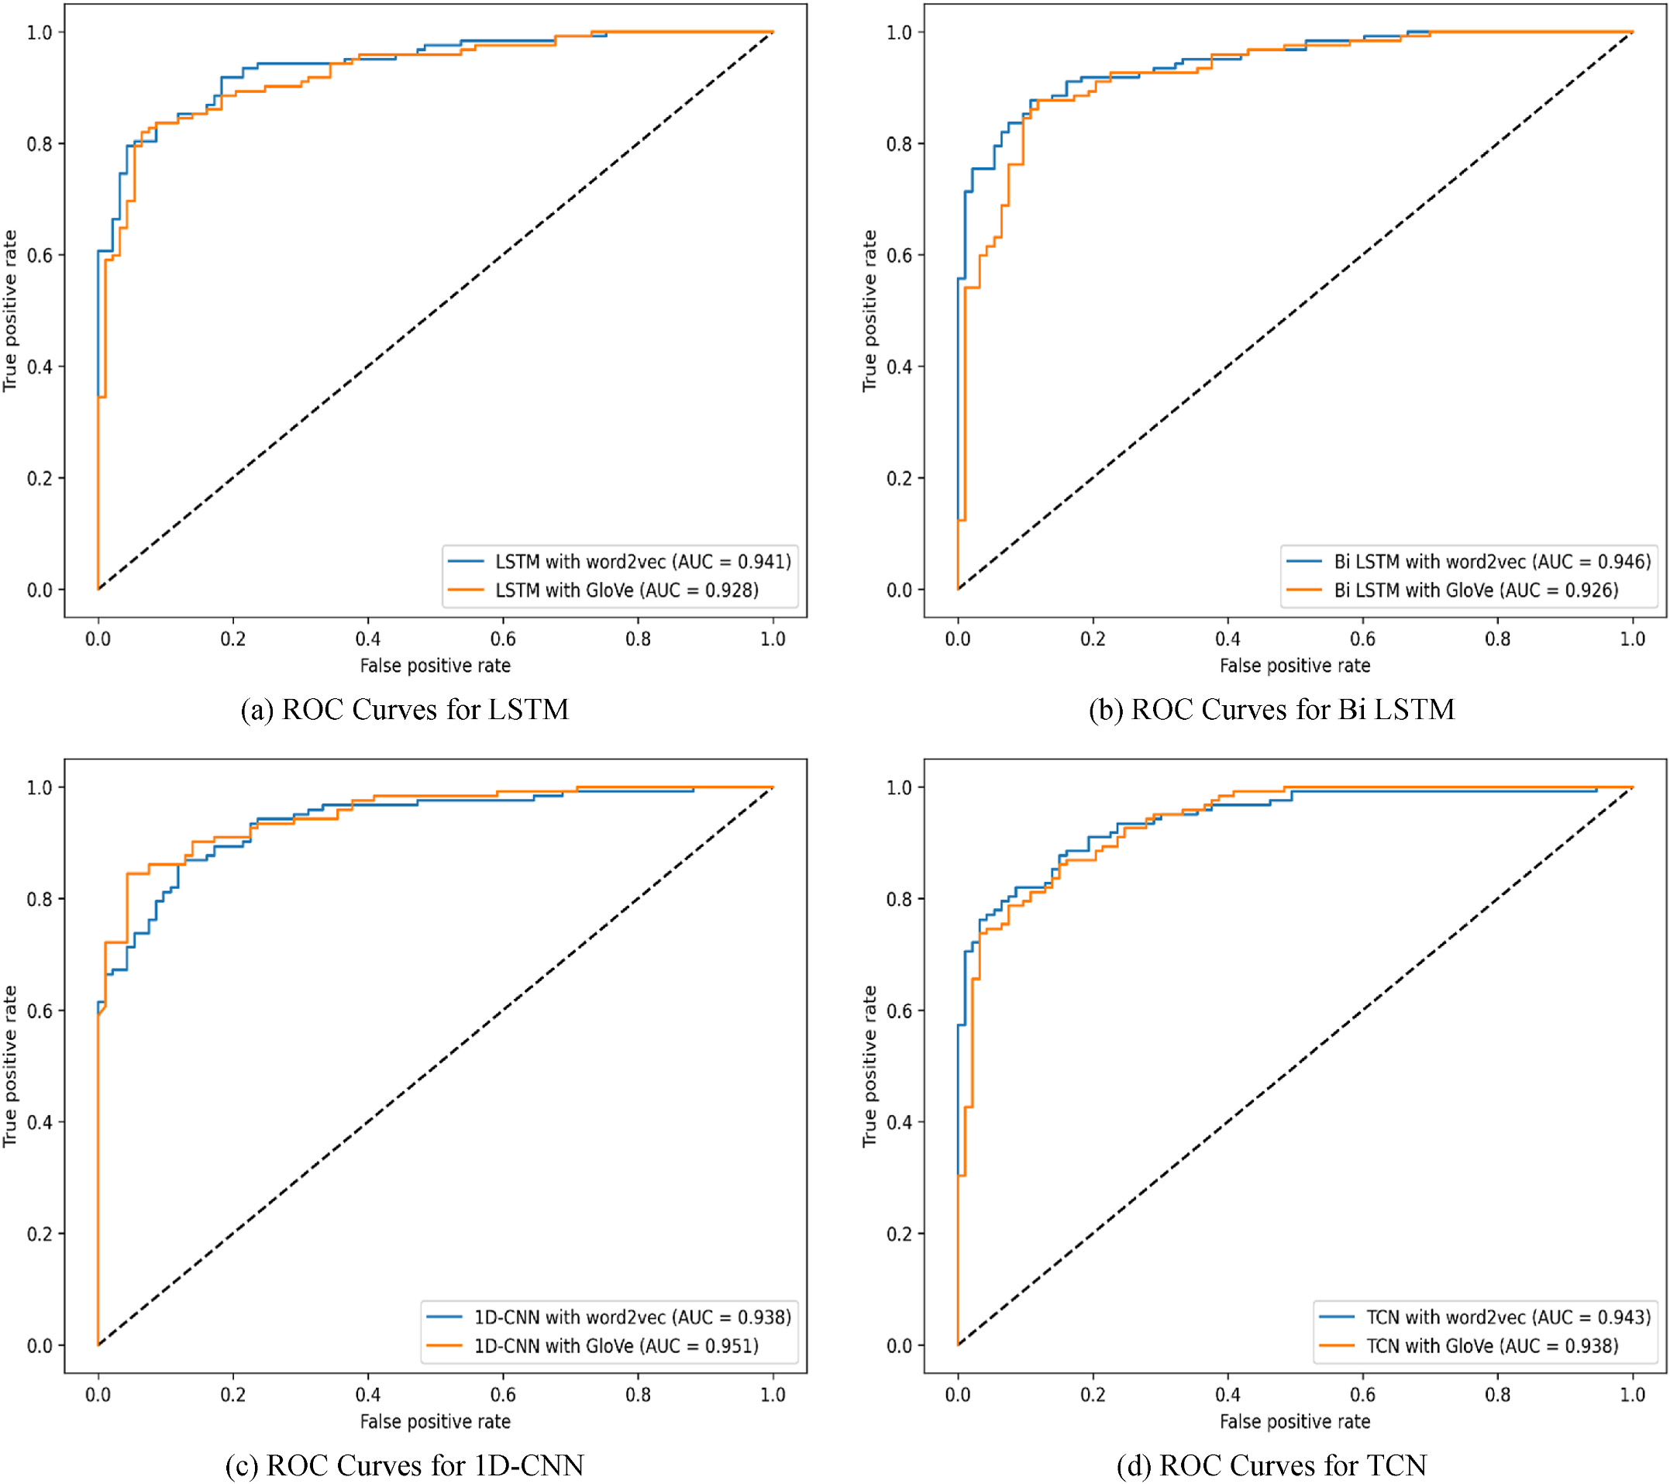

**Fig. 9.** ROC curves for deep learning models.

**5. Conclusion and future works**

Public sentiments towards a vaccine play a crucial role in alleviating the adverse effects of an epidemic. And it also helps to identify whether the vaccine is working effectively or not. This study has analyzed the Bangladeshi citizens’ opinions towards the COVID-19 vaccines and the ongoing vaccination campaign. To do so, the opinions of the Bangla-deshi netizens have been collected from different social media sites. This study considered the opinions of the netizens between the timeline June 2020 and July 2021. The polarity of the statements of the netizens was labelled with the help of seven volunteers. For validating the reliability of the polarity labelling of the volunteers, inter-rater reliability tests like Fleiss’ Kappa and Krippendorff’s Alpha reliability tests were performed.

By analyzing the polarity of opinions, it can be stated that the ma-jority of the statements were positive regarding the vaccine after the vaccination campaign was started. Topic modelling using the LDA model was performed to extract the latent topics of the positive and negative statements of the netizens. In the positive opinions, the neti-zens expressed their gratitude towards the government for taking

11

*Md.S. Zulfiker et al.*  *Array 15 (2022) 100204*

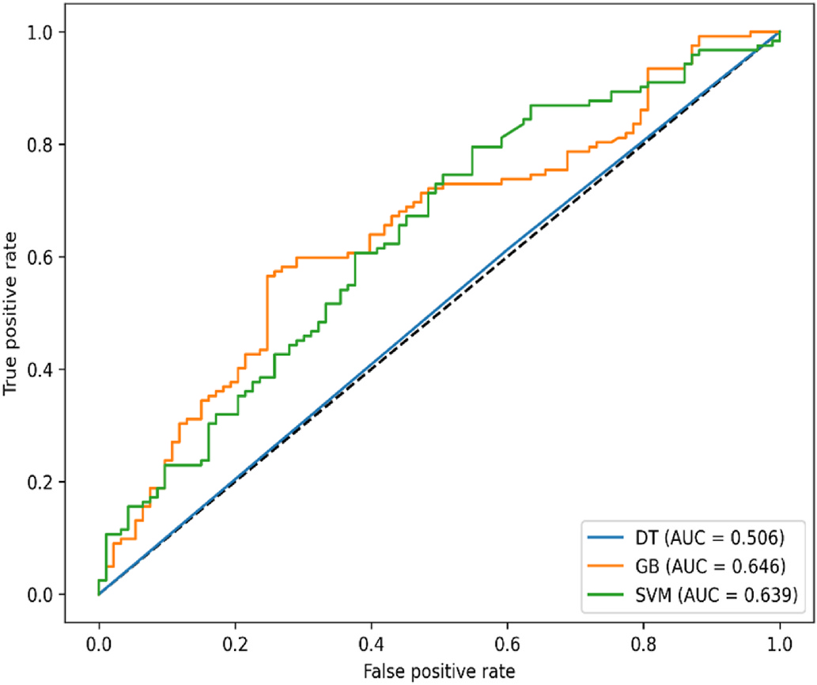

**Fig. 10.** ROC curves for traditional machine learning models.

**Credit author statement**

**Md. Sabab Zulfiker**: Methodology, Software, Formal analysis, Writing - Original Draft. **Nasrin Kabir**: Data Curation, Visualization, Formal analysis, Writing - Original Draft. **Al Amin Biswas:** Conceptu-alization**,** Formal analysis, Investigation, Writing - Original Draft. **Sun-jare Zulfiker:** Data Curation, Writing - Original Draft**. Mohammad Shorif Uddin:** Supervision, Writing - Review & Editing.

**Declaration of competing interest**

The authors declare that they have no known competing financial interests or personal relationships that could have appeared to influence the work reported in this paper.

**References**

[1] Naseem U, Razzak I, Khushi M, Eklund PW, Kim J. COVIDSenti: a large-scale benchmark Twitter data set for COVID-19 sentiment analysis. IEEE Trans. Comput.

Soc. Syst. Aug. 2021;8(4):1003–15. <https://doi.org/10.1109/TCSS.2021.3051189>. [2] WHO coronavirus (COVID-19) dash[board.](https://doi.org/10.1109/TCSS.2021.3051189) <https://covid19.who.int>[. [Accessed 5](https://doi.org/10.1109/TCSS.2021.3051189)  February 2022].

[3] Bangladesh: WHO coronavirus disease (COVID-19) dashboard with vaccination data. <https://covid19.who.int/region/searo/country/bd>. [Accessed 5 February 2022][.](https://covid19.who.int/region/searo/country/bd)

[4] Zulfiker MS, Kabir N, Ali HM, Haque MR, Akter M, Uddin MS. Sentiment analysis based on users’ emotional reactions about ride-sharing services on Facebook and Twitter. In: Uddin MS, Bansal JC, editors. Proceedings of international joint conference on computational intelligence. Singapore: Springer Singapore; 2020. p. 397–408. <https://doi.org/10.1007/978-981-15-3607-6_32>.

12